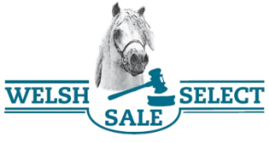
Newsletter
2nd edition of the Welsh select sale & Youngstock show 2018
On behalf of the Wels select sale & Youngstock show foundation, we would like to invite you for the 2nd edition of our Welsh event. After a successful first edition we organize again a Youngstock show and the Welsh select sale. This day will be on Saturday 6 October 2018 at the beautiful location of “de nieuwe heuvel in Lunteren, Netherlands. The foundation hereby offers the opportunity to bring the buyer and seller together, and also a social opportunity after the show season.
Youngstock show
In the morning we have the Youngstock show. The judges for this year are Hannah and Ellie Owens from the Cascob stud from Wales. The complete program will be published on the website as soon as possible. It’s possible to enter ponies for the show until Sunday 23e of September 2018.
After the lunchbreak we start with the 2nd edition of the Welsh select sale. The Welsh select sale is open to every Welsh ponies who is registered with a recognized Welsh studbook. The sale is suitable for both breeders and users of Welsh ponies. The sale ponies will be published and promoted on our website and Facebook page. You can enter for the auction until Sunday 23 September 2018.
We would like to invite you cordially for this event and we would like to see you on 6st of October 2018 in Lunteren, the Netherlands.
More information can be found on www.welshselectsale.nl or info@welshselectsale.nl
